SOLID GROUND CONSULTING
Zoom User’s Guide

Table of Contents
Zoom Platform 3
What you need to get started 3
Download Zoom 3
Zoom Desktop Client 3
Zoom Menu Bar 4
Scheduling a Meeting 4
Waiting Room 6
Join a Meeting 8
Join by Phone Only 8
Share Content During a Meeting 8
Annotate Shared Content 9
Record and Share a Meeting 9
Privacy Options 9
Require a Meeting Password 9
Using Polling 10
Using Breakout Rooms 13
Using the Whiteboard 17
What to do if You’re Having Trouble 17
3 Examples of Useful Poll Questions 18

Zoom Platform

Zoom is a cloud-based meeting tool which combines video conferencing, online meetings, and mobile collaboration into one platform. Its dependable, high-quality and easy to use design have made it so much easier for groups around the world to connect and collaborate.

Note: You do not need to purchase a Zoom account to participate in a Zoom meeting.

What you need to get started
- An internet connected computer, laptop, or device
- A external webcam or built-in camera on your computer
- A headset or ear buds (especially if you’re participating with a laptop)
OR Join by Phone
- If you don’t have access to a computer or your computer, laptop or device are unable to receive audio.

Download Zoom

Install the latest Zoom Client for Meetings or Mobile App

The Zoom web browser plug-in will download automatically when you start or join your first Zoom meeting. The plug-in is also available for manual download here:
https://zoom.us/download

You can also use your mobile device to start and join meetings. Apps for iOS and Android can be found here:
- iPhone/iPad: https://apple.co/397Fl4N
- Android: https://bit.ly/33Fyi2c

Zoom Desktop Client
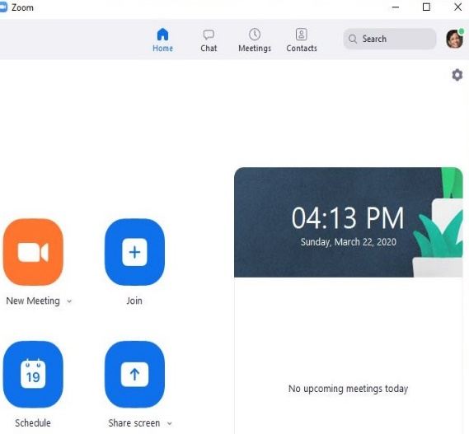

Zoom Menu Bar
The Zoom menu bar appears at the bottom of the Zoom window once the meeting begins. If you don’t see the menu bar, move your mouse slightly and the bar will appear. (The bar disappears after a few seconds when in full-screen mode.)
1 2 3 4 5 6 7 8
You Can…
- Mute/Unmute your audio (not the audio of participants).
- Stop/start your video.
- Configure your settings for items like audio and video. (If you have trouble hearing when you get connected, this is the place to check. See How to Configure the Settings below.)
- View a list of participants.
- Share your screen
- Record meeting
- Leave the video meeting

Scheduling a Meeting
- Open your Zoom client.
- Click on the Schedule icon.
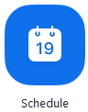
This will open the scheduler window.

- Select your meeting settings. Note that some of these options might not be available if they were disabled and locked to the off position at the account or group level.
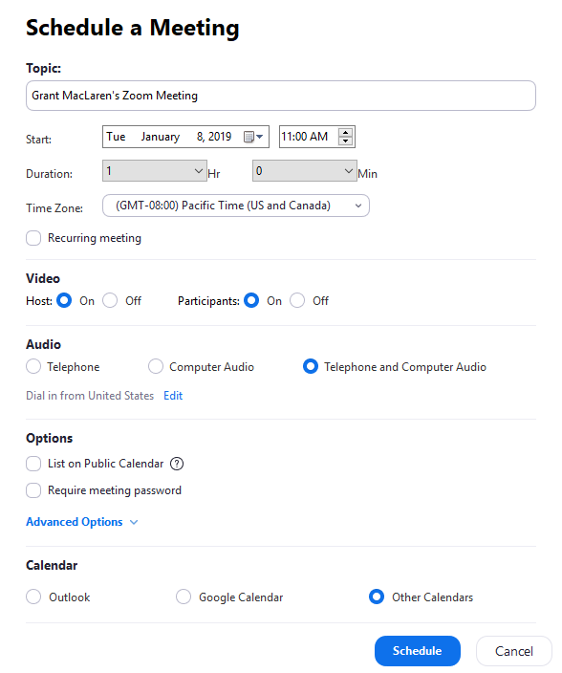
  - Topic: Enter name for your meeting.
  - Start: Select a date and time for your meeting. You can start your meeting at any time before the scheduled time.
  - Duration: Choose the approximate duration of the meeting. This is only for scheduling purposes. The meeting will not end after this length of time.
  - Time Zone: By default, Zoom will use your computer's time zone. Click the drop-down menu to select a different time zone.
  - Recurring meeting: Choose if you would like a recurring meeting (the meeting ID will remain the same for each session).
    - Host: Choose if you would like the host video on or off when joining the meeting. Even if you choose off, the host will have the option to start their video.
    - Participant: Choose if you would like the participants' videos on or off when joining the meeting. Even if you turn off, the participants will have the option to start their video.
  - Audio: Choose whether to allow users to call in via Telephone only, Computer Audio only, both, or 3rd Party Audio (if enabled for your account).
    - Advanced Options: Click on the arrow to view additional meeting options.
    - Require meeting password: You can select and input your meeting password here. Joining participants will be required to input this before joining your scheduled meeting.
    - Enable join before host: Allow participants to join the meeting without you or before you join. The meeting will end after 40-minutes for Basic (free) users if 3 or more people join the meeting.
    - Mute participants on entry: If join before host is not enabled, this will mute participants as they join the meeting. Participants can unmute themselves after joining the meeting.
Use Personal Meeting ID: Check this if you want to use your Personal Meeting ID. If not selected, a random unique meeting ID will be generated.
    - Record the meeting automatically: Check this if you want the meeting to be automatically recorded. Select if you want it to be recorded locally (to your computer) or to the cloud (zoom.us/recording).
    - Schedule For: If you have scheduling privilege for another user, you will be able to choose who you want to schedule for from the drop-down menu.
    - Alternative hosts: Enter the email address of another Zoom user who is licensed, on your account to allow them to start the meeting in your absence. Read more about Alternative Host.
  - Calendar: Select a calendar service to add the meeting to and send out invites to participants.
- Click Schedule to finish, and open the selected calendar service to add the meeting.
Note:
  - If you are scheduling a recurring meeting, you will need to set the recurrence in your calendar service.
  - Choosing Other Calendars will allow you to copy and paste the scheduled meeting information such as date, time, and meeting URL.

Waiting Room
The waiting room allows the host to control when a participant joins the meeting.

How to use the waiting room
- Enable the meeting room:
  - Go to My Meeting Settings
  - Check the box next to Waiting Room
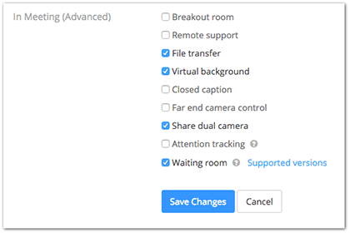
  - Click Save Changes.﻿
- Use the waiting room in a meeting:
  - Click Manage Participants
  - Click More, select Put attendee in waiting room.
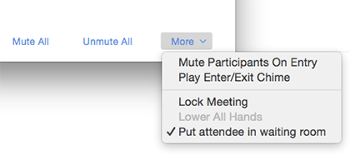

  - Once a participant joins, you will see the option to either Admit or Remove the user.
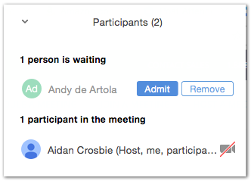
  - Select Admit to allow them to join the meeting.

Note: While a participant is waiting to enter the meeting, they will see the message: "Please wait, the meeting host will let you in soon."
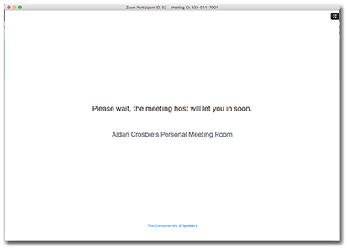

Join a Meeting
- Navigate to Zoom and click the Join a Meeting link at the top of the page, then enter the meeting id.
Note: Zoom meetings can be attended via phone and computer. Meeting participants will receive an event invitation from the host with link to join the meeting.
- Make a choice when prompted for your audio option: computer or phone.

Microsoft Outlook Plug-in
The Microsoft Outlook plug-in is a software component that provides you with the ability to participate in meetings from your Outlook application on your personal computer. The Outlook plugin syncs free/ busy times to the Zoom Client based on your Outlook Calendar events.

How to join a meeting from the Outlook plug-in
- Open the Outlook calendar.
- Open the appointment.
- Choose the URL to the Zoom meeting.
https://support.zoom.us/hc/en-us/articles/200881399-Microsoft-Outlook-plugin-desktop-

Join by Phone Only

You can join a Zoom meeting via audio conferencing using a telephone.
- Dial the number provided in the Zoom meeting invitation
- You will be prompted to enter the meeting ID - the nine (9) or ten (10) digit ID provided to you by the host
- You will be prompted to enter your unique participant ID, Press # to skip
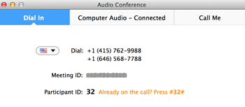

Share Content During a Meeting
- From the Zoom client, choose Share Screen.
- Open the file to be opened.
- Choose Share Screen

Annotate Shared Content
- During the meeting, choose Share content.
Note: Content shared from an Android device cannot be annotated.
- From the menu, choose Annotate from the meeting menu.
Note: Annotation features do not function with Android devices.
- From the Annotate menu, choose one of the annotation features.

Record and Share a Meeting
Local recording is available for all accounts. By default, hosts are the only people who can record. Other participants can be granted the ability to record.
Once your meeting has started, press the Record button.
You also choose recording when scheduling your meeting in the settings.
The recording can be started and stopped multiple times. Each time the user clicks Stop, Zoom will store a snippet.
- End your meeting.
- Zoom converts the recording, collates all snippets, and stores one file, named playback.m3u on your computer.
- From the Zoom interface, select Meetings from the bottom of the home screen.
- Zoom presents a list of recorded meetings, and their paths, stored on your local hard drive.
- Navigate to the path you want to share.

Privacy Options
You have two key options to make a Zoom meeting private:
- Require a meeting password - Set a password for your guests to enter. Good increase in security, but requires you to distribute the password.
- Use the waiting room - Control when your guests are admitted to the meeting. Best for smaller meetings.

Require a Meeting Password
Requiring a password is a way to increase the security of your meeting. You can send your chosen password to your attendees via email or chat. Be sure to remind attendees not to share the password.

How to require a password
- Open your zoom application and log in to Zoom,
- Click on the Schedule icon.
- Under Meeting Options, check Require meeting password.
- Click Schedule.

Using Polling
Zoom has a feature where meeting hosts can create polls, which can be used for voting or for gauging opinions. Participants then respond to the polls.

Creating a Poll
- Go to the Meetings page and click on your scheduled meeting. If you do not have a scheduled meeting, schedule a meeting now.
- From the meeting management page, scroll to the bottom to find the Poll option. Click Add to begin creating the poll.
- Enter a title and your first question.
  - (Optional) Check the box to make the poll anonymous, which will keep the participant's polling information anonymous in the meeting and in the reports.
  - Select whether you want the question to be single choice (participants can only choose one answer) or multiple choice question (participants can choose multiple answers).
- Type in the answers to your question and click Save at the bottom
- To add a new question, click Add a Question to create a new question for that particular poll.
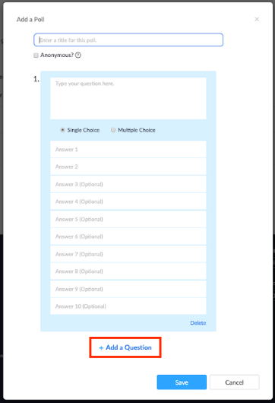
You can add more polls by repeating Step 2.
You can also create a poll by clicking Polling during the meeting. This will open up your default web browser where you can add additional polls or questions.
Note: You can only create a max of 25 polls for a single meeting.
Launching a Poll
- Start the scheduled Zoom meeting that has polling enabled.
- Select the Polling option in the menu bar.
- Select the poll you would like to launch.
- Click Launch Poll.
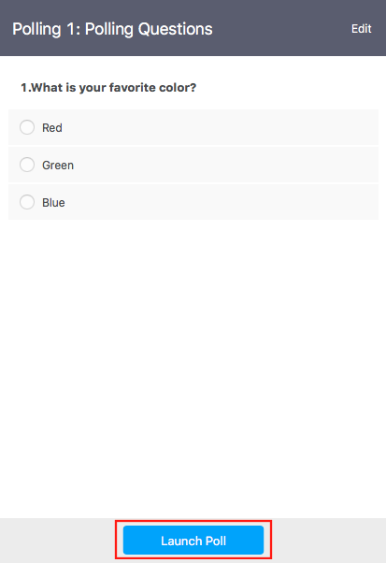
- The participants in the meeting will now be prompted to answer the polling questions. The host will be able to see the results live.
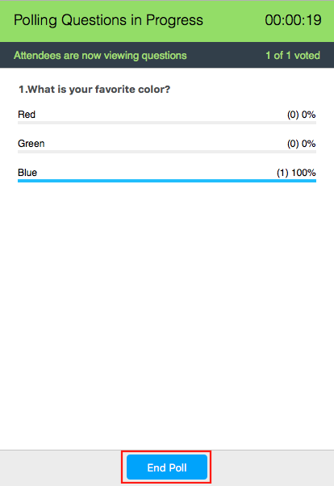
- Once you would like to stop the poll, click End Poll.
- If you would like to share the results to the participants in the meeting, click Share Results.
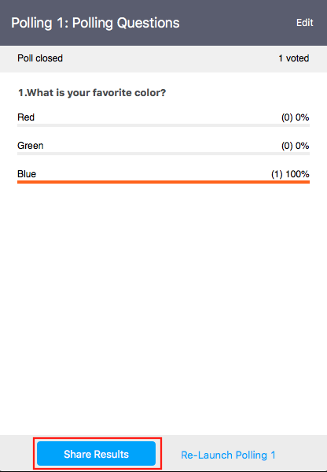
- Participants will then see the results of the polling questions.
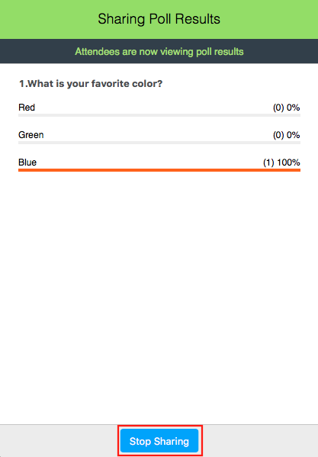

Downloading a Report of Poll Results
You can download a report of the poll results after the meeting. If registration was turned on and the poll was not anonymous, it will list the participants' names and email addresses. If registration was not on, it will show the results, but list the users as "Guest". If the poll was anonymous, it will show "anonymous" for the participants' names and email addresses.

Using Breakout Rooms

Breakout rooms are sessions that are split off from the main Zoom meeting. They allow the participants to meet in smaller groups. Breakout rooms can be used for collaboration and discussion of the meeting.

Breakout rooms allow you to split your Zoom meeting in up to 50 separate sessions. The meeting host can choose to split the participants of the meeting into these separate sessions automatically or manually, and can switch between sessions at any time.
- Up to 50 breakout rooms can be created
- Max 200 total participants across all breakout rooms
- Breakout room participants have full audio, video and screen share capabilities
You can also share Participating in Breakout Rooms with your meeting participants for some information on using breakout rooms as a participant.

Prerequisites
- Join the meeting by the Zoom desktop client, mobile app, phone, or H.323/SIP device
- Invitation to join breakout rooms from the meeting host
Note: Users joined into the Zoom meeting from the Zoom Desktop Client, Zoom Mobile App, or H.323/SIP devices can participate in breakout rooms. Users joined via the web client, Chromebooks/Chrome OS or Zoom Rooms are unable to join Breakout Rooms, but the main room can be used as an alternative session for these users.

Windows | Mac

Joining a Breakout Room
- The host will need to invite you to join the breakout room.
- Click Join.
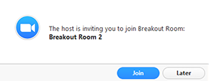
- If you choose Later, you can join by clicking the Breakout Rooms option in your meeting controls.
- Click Join Breakout Room.
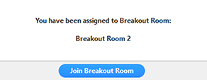

Participating in the Breakout Room
Once you've joined the breakout room, you will have full controls similar to the meeting. You can:
- Mute/Unmute to speak
- Start/Stop Video
- Participants - view the Participants list
- Share screen - read more about screen sharing
- Chat - type messages to the other participants in your breakout room
- Record - you can record the Breakout Room locally if the host gives you recording permission. Read more about local recording.
- Ask for Help - request help from the meeting host

Asking for Help
If you click Ask for Help, it will notify the meeting host that you need assistance and they will be asked to join your breakout room.
- Click Ask for Help in the meeting controls.
- Confirm that you would like assistance by clicking Invite Host.
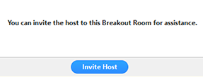

Recording while in a Breakout Room
- Ask the host for permission to record. The host needs to allow recording before opening the breakout rooms. If the host has already open the breakouts rooms, they can join your breakout room to allow you to record.
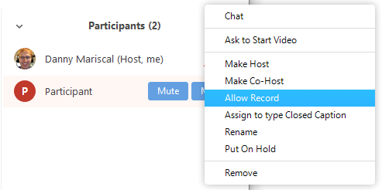
- Click Record in the meeting controls to start a local recording.
- The host will need to invite you to join the breakout room.
- Click the pause or stop icon in the meeting controls to pause or stop the recording.
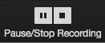
The recording can also be stopped or paused by clicking the indicator in the top left corner.
Managing Breakout Rooms
Zoom.us has created a great tutorial on managing breakout rooms. It has everything you will need to know about starting and managing breakout rooms.

Pre-assigning participants to breakout rooms using the web portal
- Sign in to the Zoom web portal.
- Click Meetings and schedule a meeting.
Note: Make sure to enable join before host.
- In the Meeting Options section, select Breakout Room pre-assign and click Create Rooms.
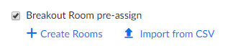
- Click the plus icon beside Rooms to add breakout rooms.
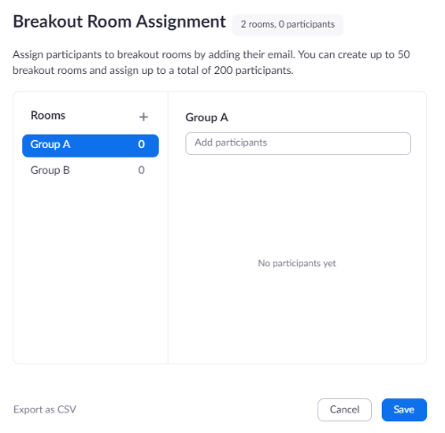
- Hover over the default breakout room name and click the pencil icon to rename it.
- In the Add participants text box, search for participants' name or email address to add them to the breakout room.
Note: You can add internal Zoom users that are in the same account. To pre-assign participants that are external Zoom users.
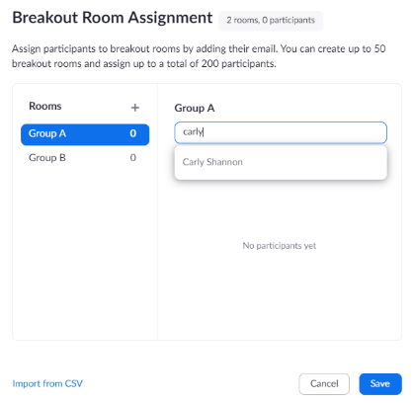
- (Optional) Use these options to edit your breakout rooms and participants:
  - Click and drag a participant's email address to change the order.
  - Hover over a participant's name to see options to move them to another room or remove them from the current room.
  - To delete a breakout room, hover the room name in the left panel and click the trash bin icon.
- Click Save.

Leaving the Breakout Room
You can leave the breakout room and return to the main meeting session at any time, or you can leave the meeting entirely from the breakout room.
- Click Leave Breakout Room.
- Choose if you want to leave the breakout room or the entire meeting.
- When the host ends the breakout rooms, you will be notified and given the option to return to the main room immediately, or in 60 seconds.

If the breakout rooms icon doesn't appear:

- Click the Settings option in the left navigation bar.
- Click the "In Meeting (Advanced) option and navigate to the Breakout Room option and verify that the setting is enabled. If the setting is disabled, click the toggle to enable it. If a verification dialog displays, choose Turn On to verify the change.
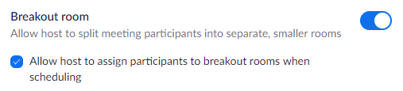
Click the checkbox to allow meeting hosts to pre-assign participants to breakout rooms

Using the Whiteboard
The Whiteboard feature allows you to share a Whiteboard that you can annotate on with others. To use the Whiteboard 1. Once you have joined the meeting, click Share Screen from the meeting toolbar 2. Select Whiteboard 3. Click Share Screen 4. The Annotation tools will become available Note: You can save the Whiteboard as a PNG file. It will then be stored in the Zoom folder as ‘whiteboard.png’.

What to do if You’re Having Trouble
Here are some steps troubleshooting steps for you to try:

- For choppy video or slow loading times, close as many other programs on your computer as you can. Usually, some other program is using lots of bandwidth or memory on your computer so closing other applications helps.
- If you're having trouble with a specific program, quit it; then re-open it.
- Try searching for troubleshooting help using Google search (Google it).
- For web problems, clear your browser's cache.
- Try using a different web browser. Chrome and Firefox are the preferred Zoom browsers.
- Restarting your computer is also a good step to try.

3 Examples of Useful Poll Questions

- Create an icebreaker and get the interaction started

Ask a fun question about what’s for lunch, how the weather is where they are, or what their favorite sport is. This may seem silly, but it’s a great way to break the ice and get people interacting. It also helps to get everyone to turn on their video.

- Let your audience pick the content

If you’re giving a presentation, try letting your audience choose which content you’ll present. You’ll have to be ready to tweak your content to meet their needs – but your audience will be much more engaged. This can be a great idea for a quarterly update or all-hands meeting where you have a lot of information and a limited amount of time.

- Get input on the meeting

Want to know what they thought about the meeting? Put up a quick poll with a scale that lets them rate the content and presentation. You’ll have instant feedback and know if you need to step up your game next time, or if you’re doing a great job. And your participants don’t need to worry as their responses are anonymous.

